MARS
D.TFS-UC MR 12 Use Cases -Official Quote Automation
Version 0.03
18/12/2015

Written and Approved by:  EUROPEAN DYNAMICS  System Analyst  Christonikos Zonafos | Sign off and Date: |  | Appraisal Authority:  EUMS  Key User Representative | Sign off and Date:
Appraisal Authority:  EUROPEAN DYNAMICS  Technical Manager  Dionysios Mantelos | Sign off and Date: |  | Appraisal Authority:  EUMS  Deputy Project Manager | Sign off and Date:
Appraisal Authority:  EUROPEAN DYNAMICS  Project Manager  Tassos Sorilos | Sign off and Date: |  | Appraisal Authority:  EUROPEAN DYNAMICS  Project Manager  Leonidas Savvopoulos | Sign off and Date:
Appraisal Authority:  EUROPEAN DYNAMICS  Quality Assurance Officer  Martin Ulmann | Sign off and Date: |  | Appraisal Authority:  EEAS  Quality Assurance Officer  Roeland Lacroix | Sign off and Date:

document history
Version | Date | Author | Reason for Modification | Action^{(*)} | Confidentiality
0.01 | 20/11/2015 | EUROPEAN DYNAMICS | Creation of Document – Official Quote Automation | C | High
0.02 | 30/11/2015 | EUROPEAN DYNAMICS | Update | U | High
0.03 | 18/12/2015 | EUROPEAN DYNAMICS | Update | U | High
(*) Action: C= Creation, I=Insert, U=Update, R=Replace, D=Delete

cIRCULATION LIST
Person Name | Organisation Name
Dionysios Mantelos | EUROPEAN DYNAMICS
Christonikos Zonafos | EUROPEAN DYNAMICS
Vasilis Alexopoulos | EUROPEAN DYNAMICS
Panagiotis Vassilikopoulos | EUROPEAN DYNAMICS
Leonidas Savvopoulos | EUROPEAN DYNAMICS
Tassos Sorilos | EUROPEAN DYNAMICS
Martin Ulmann | EUROPEAN DYNAMICS
Roeland Lacroix | EEAS
Virginia Gonzalez-Ruiz | EEAS

Applicable and REFERENCE documents
Type^{(*)} | Title | Identification | Ver | Date
R1 | D.TFS Technical and Functional Specifications - MR12 | D.TFS Technical and Functional Specifications - MR12 v1.02.doc | 1.02 | 30/11/2015
R2 | D.TFS Technical and Functional Specifications - MR12 | D.TFS Technical and Functional Specifications - MR12 v1.03.doc | 1.03 | 18/12/2015
(*): Reference document, Applicable document

Table of Contents
1 Official Quote Automation 5
1.1 UC001 - Request Official Quote NEW 6
1.1.1 UC001 - Request Official Quote NEW ActivityGraph 9
1.2 UC002 - Request Official Quote Suffix 11
1.2.1 UC002 - Request Official Quote Suffix ActivityGraph 13
1.3 UC003 - Manage Official Quote FINALIZE/UPDATE 15
1.3.1 UC003 - Manage Official Quote FINALIZE/UPDATE ActivityGraph 18
1.4 UC004 - OQA WebTop Official Quote Log 20
1.4.1 UC004 - OQA WebTop Official Quote Log ActivityGraph 22
1.5 UC005 - OQA WebTop Other Tables (MARS Official Quote) 24
1.5.1 UC005 - OQA WebTop Other Tables (MARS Official Quote) ActivityGraph 26
1.6 UC006 - OQA WebTop Other Tables (MARS Official Quote Keyword) 28
1.6.1 UC006 - OQA WebTop Other Tables (MARS Official Quote Keyword) ActivityGraph 30
1.7 UC007 - OQA WebTop Other Tables (MARS Official Quote Prefix) 32
1.7.1 UC007 - OQA WebTop Other Tables (MARS Official Quote Prefix) ActivityGraph 34
1.8 UC008 - OQA WebTop Other Tables (MARS Official Quote Range) 36
1.8.1 UC008 - OQA WebTop Other Tables (MARS Official Quote Range) ActivityGraph 38

Table of Figures
Figure 1: Official Quote Automation 5
Figure 2: UC001 - Request Official Quote NEW 8
Figure 3: UC001 - Request Official Quote NEW ActivityGraph 10
Figure 4: UC002 - Request Official Quote Suffix 13
Figure 5: UC002 - Request Official Quote Suffix ActivityGraph 14
Figure 6: UC003 - Manage Official Quote FINALIZE/UPDATE 17
Figure 7: UC003 - Manage Official Quote FINALIZE/UPDATE ActivityGraph 19
Figure 8: UC004 - OQA WebTop Official Quote Log 21
Figure 9: UC004 - OQA WebTop Official Quote Log ActivityGraph 23
Figure 10: UC005 - OQA WebTop Other Tables (MARS Official Quote) 25
Figure 11: UC005 - OQA WebTop Other Tables (MARS Official Quote) ActivityGraph 27
Figure 12: UC006 - OQA WebTop Other Tables (MARS Official Quote Keyword) 29
Figure 13: UC006 - UC005 - OQA WebTop Other Tables (MARS Official Quote Keyword) ActivityGraph 31
Figure 14: UC007 - OQA WebTop Other Tables (MARS Official Quote Prefix) 33
Figure 15: UC007 - OQA WebTop Other Tables (MARS Official Quote Prefix) ActivityGraph 35
Figure 16:UC008 - OQA WebTop Other Tables (MARS Official Quote Range) 37
Figure 17: UC008 - OQA WebTop Other Tables (MARS Official Quote Range) ActivityGraph 39

Official Quote Automation

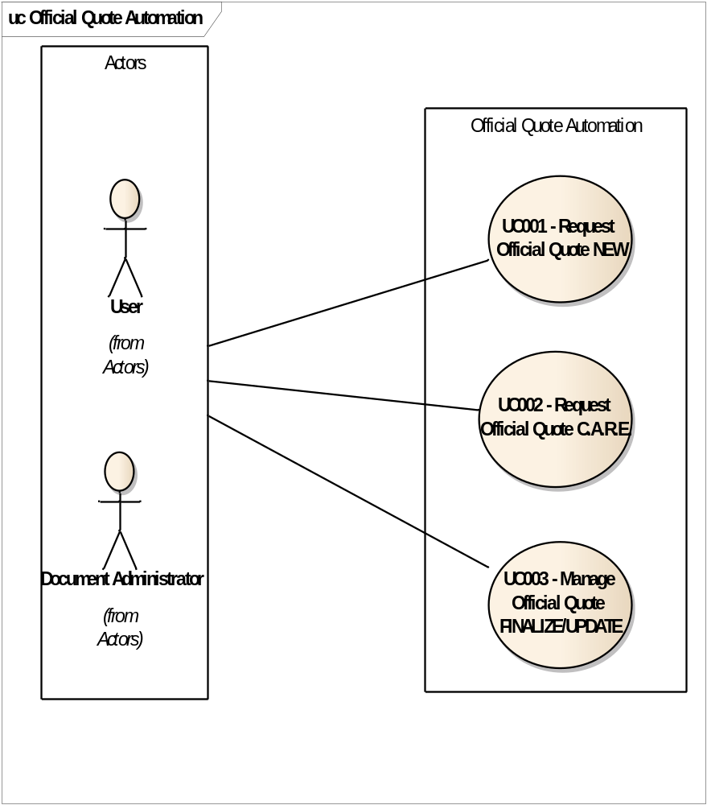
Figure 1: Official Quote Automation

UC001 - Request Official Quote NEW

Name | UC001 - Request Official Quote NEW
Description | Allows a User to Request a NEW Official Quote
Primary Actor | User
Minimum Constrains | User is logged into MARS  User belongs to MARS OFFICIAL QUOTES USERS group

Scenario | Basic Path | Course | Basic Path

Step |  | Actor |  | Action
 | 1 |  | User |  | User selects the Request Official Quote option.

2 | System | System displays the Select Official Quote Mode form.

3 | User | User selects 1. - NEW Official Quote.

4 | System | System displays the NEW Official Quote form.

5 | System | System prefills the Official Quote number field with the next available value and disables the "Suffixes" fields.

6 | User | User selects OK to Request the Official Quote.

Junction splitter step |  | Course |  | Scenario | Association Step
6a |  | Alternate |  | User clicks Cancel | End
6b |  | Alternate |  | User closes the form | End
7 | System |  | System displays a dialog informing the User that the Official Quote will be copied to Clipboard.

8 | User | User clicks ok to copy the Official Quote to Clipboard.

9 | System | System copies the Official Quote to Clipboard.

10 | System | System updates the Official Quote Status to Requested and reserves the current Number. The user ID and the timestamp are logged.

Scenario | User clicks Cancel | Course | Alternate

Step |  | Actor |  | Action
 | 1 |  | User |  | User selects Cancel for the Official Quote

2 | System | System updates the Official Quote Status to Available

Scenario | User closes the form | Course | Alternate

Step |  | Actor |  | Action
 | 1 |  | User |  | User clicks the top-right Close button (x).

2 | System | System updates the Official Quote Status to Available

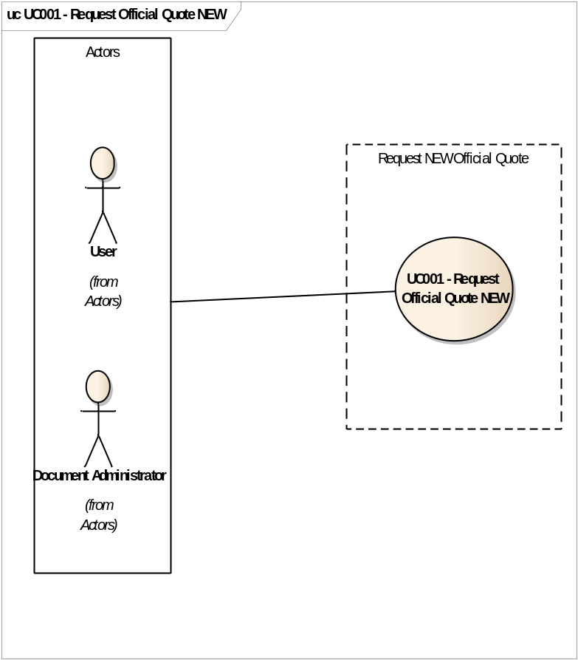
Figure 2: UC001 - Request Official Quote NEW

UC001 - Request Official Quote NEW ActivityGraph

Name | UC001 - Request Official Quote NEW ActivityGraph
Description | Allows a User to Request a NEW Official Quote
Primary Actor | User
Minimum Constrains | User is logged into MARS  User belongs to MARS OFFICIAL QUOTES USERS group
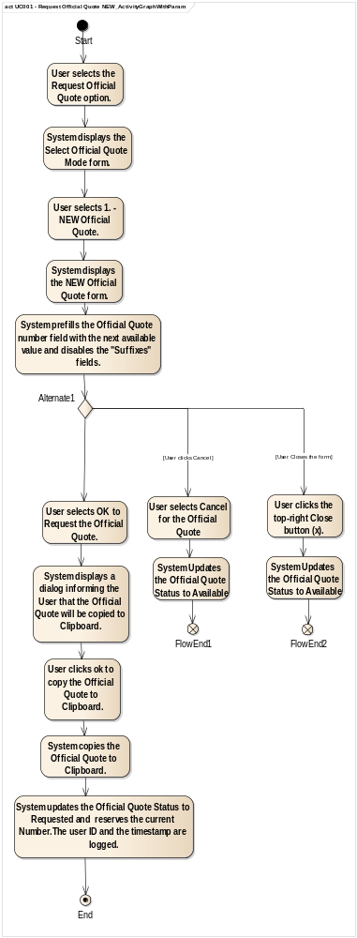
Figure 3: UC001 - Request Official Quote NEW ActivityGraph

UC002 - Request Official Quote Suffix

Name | UC002 - Request Official Quote Suffix
Description | Allows a User to Request a Suffix Official Quote
Primary Actor | User
Minimum Constrains | User is logged into MARS  User belongs to MARS OFFICIAL QUOTES USERS group

Scenario | Basic Path | Course | Basic Path

Step |  | Actor |  | Action
 | 1 |  | System |  | System displays the Official Quote form pre-populated with the latest iterations of each Official Number Finalized by all the users with the same Originator as the current user.

2 | User | User selects an Official Quote.

3 | System | System displays the NEW Official Quote form pre-populated with the selected Official Quote.

4 | User | User selects a Suffix value by checking the corresponding check-box.

5 | System | System validates the selection and applies the selected Suffix value.

6 | User | User selects OK.

Junction splitter step |  | Course |  | Scenario | Association Step
6a |  | Alternate |  | User clicks Cancel | End
6b |  | Alternate |  | No Suffix value selected | 4
6c |  | Alternate |  | User closes the form | End
7 | System |  | System displays a dialog informing the User that the Official Quote will be copied to Clipboard.

8 | User | User clicks ok to copy the Official Quote to Clipboard.

9 | System | System copies the Official Quote to Clipboard.

10 | System | System registers the Suffix Official Quote with status Requested. The user ID and the timestamp are logged.

Scenario | User clicks Cancel | Course | Alternate

Step |  | Actor |  | Action
 | 1 |  | User |  | User selects Cancel

2 | System | System closes the NEW Official Quote form without saving the Official Quote

Scenario | No Suffix value selected | Course | Alternate

Step |  | Actor |  | Action
 | 1 |  | User |  | User clicks OK without selecting a Suffix value from the corresponding checkboxes

Scenario | User closes the form | Course | Alternate

Step |  | Actor |  | Action
 | 1 |  | User |  | User clicks the top-right Close button (x).

2 | System | System closes the NEW Official Quote form without saving the Official Quote.

selects

clicks

clicks

selects

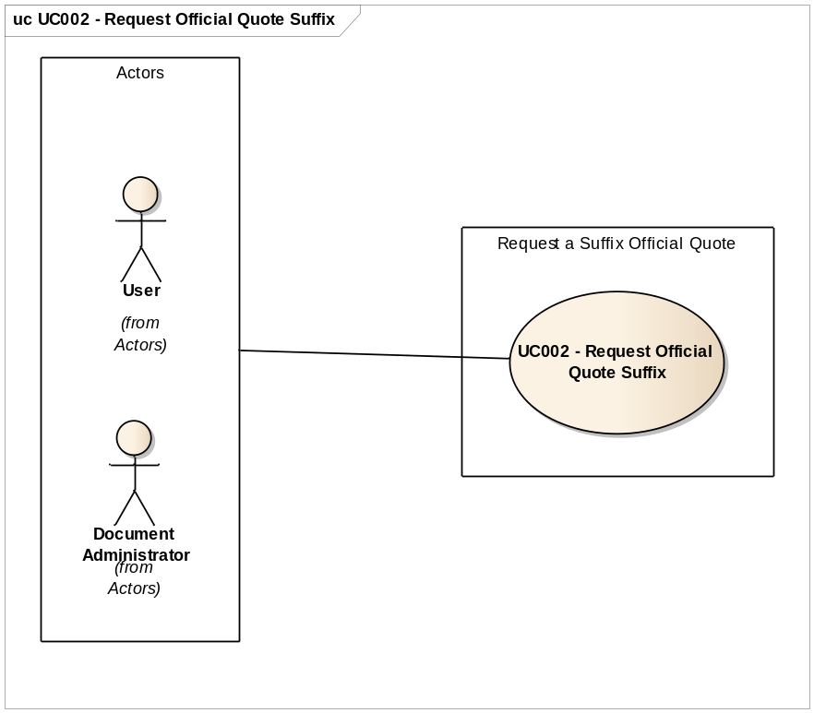
Figure 4: UC002 - Request Official Quote Suffix

UC002 - Request Official Quote Suffix ActivityGraph

Name | UC002 - Request Official Quote Suffix ActivityGraph
Description | Allows a User to Request a Suffix Official Quote
Primary Actor | User
Minimum Constrains | User is logged into MARS  User belongs to MARS OFFICIAL QUOTES USERS group
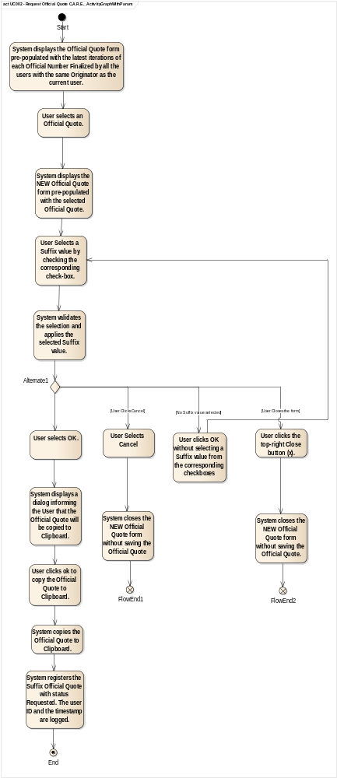
Figure 5: UC002 - Request Official Quote Suffix ActivityGraph

UC003 - Manage Official Quote FINALIZE/UPDATE

Name | UC003 - Manage Official Quote FINALIZE/UPDATE
Description | Allows a User to Link an Official Quote to a document in DM an update the Official Quote fields when required.
Primary Actor | User
Minimum Constrains | User is logged into MARS  User belongs to MARS OFFICIAL QUOTES USERS group  User has View/Edit Profile and View Document Content access rights on the document  Selected document has classification Confidential or Secret  Selected document belongs to an Official Category

Scenario | Basic Path | Course | Basic Path

Step |  | Actor |  | Action
 | 1 |  | User |  | User right-clicks a document in DM.

2 | User | User selects Finalize/Update Official Quote.

3 | System | System displays the Finalize/Update Official Quote form.

4 | User | User clicks to select an Official Quote.

Junction splitter step |  | Course |  | Scenario | Association Step
4a |  | Alternate |  | Official Quote exists for the selected document | 8
5 | System |  | System displays the Official Quote form pre-populated with the Requested Official Quotes by all the users with the same Originator as the current user.

6 | User | User selects an Official Quote.

7 | System | System updates the Official Quote text field of the Finalize/Update Official Quote form.

8 | User | User updates the Official Quote fields with the necessary information.

9 | User | User clicks OK.

Junction splitter step |  | Course |  | Scenario | Association Step
9a |  | Alternate |  | User clicks cancel | End
9b |  | Alternate |  | User closes the form | End
10 | System |  | System links the selected Official Quote with the selected document and updates the Official Quote status to Finalize.

11 | System | System updates the Document Number field of the Document profile with the Official Quote number, followed by the previously existing contents, in the form "###### - Content".

12 | System | System logs the Official Quote in the Document History and in the History Log. The user ID and the timestamp are logged as well.

Scenario | Official Quote exists for the selected document | Course | Alternate

Step |  | Actor |  | Action
 | 1 |  | System |  | An Official Quote has already been linked to the document.

Scenario | User clicks cancel | Course | Alternate

Step |  | Actor |  | Action
 | 1 |  | User |  | User clicks Cancel button.

2 | System | System closes the form without storing anything

Scenario | User closes the form | Course | Alternate

Step |  |  |  | Actor |  | Action
 |  |  | 1 |  | User |  | User clicks the top-right Close button (x).

2 | System | System closes the form without storing anything

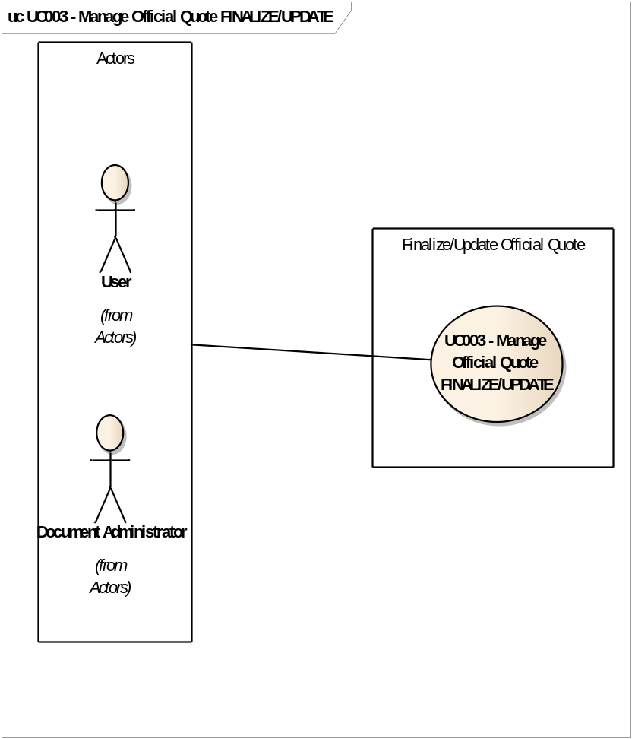
Figure 6: UC003 - Manage Official Quote FINALIZE/UPDATE

UC003 - Manage Official Quote FINALIZE/UPDATE ActivityGraph

Name | UC003 - Manage Official Quote FINALIZE/UPDATE ActivityGraph
Description | Allows a User to Link an Official Quote to a document in DM an update the Official Quote fields when required.
Primary Actor | User
Minimum Constrains | User is logged into MARS  User belongs to MARS OFFICIAL QUOTES USERS group  User has View/Edit Profile and View Document Content access rights on the document  Selected document has classification Confidential or Secret  Selected document belongs to an Official Category
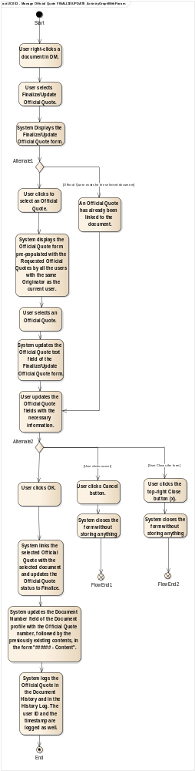
Figure 7: UC003 - Manage Official Quote FINALIZE/UPDATE ActivityGraph

UC004 - OQA WebTop Official Quote Log

Name | UC004 - OQA WebTop Official Quote Log
Description | User views the Official Quote Log.
Primary Actor | Document Administrator
Minimum Constrains | User has administrator rights

Scenario | Basic Path | Course | Basic Path

Step |  | Actor |  | Action
 | 1 |  | User |  | User logs into WebTop.

2 | User | User navigates to DM Admin tab.

3 | User | User navigates to Log Pages tab.

4 | User | User selects the Official Quote Log.

5 | User | User presses the Search button.

Junction splitter step |  | Course |  | Scenario | Association Step
5a |  | Alternate |  | User enters search criteria | 6
6 | System |  | System populates the table with all the corresponding Official Quote Actions.

Scenario | User enters search criteria | Course | Alternate

Step |  | Actor |  | Action
 | 1 |  | User |  | User selects one or more criteria (Date Range, Official Quote, User Id, Action) to narrow down the expected Results.

2 | User | User presses the search button.

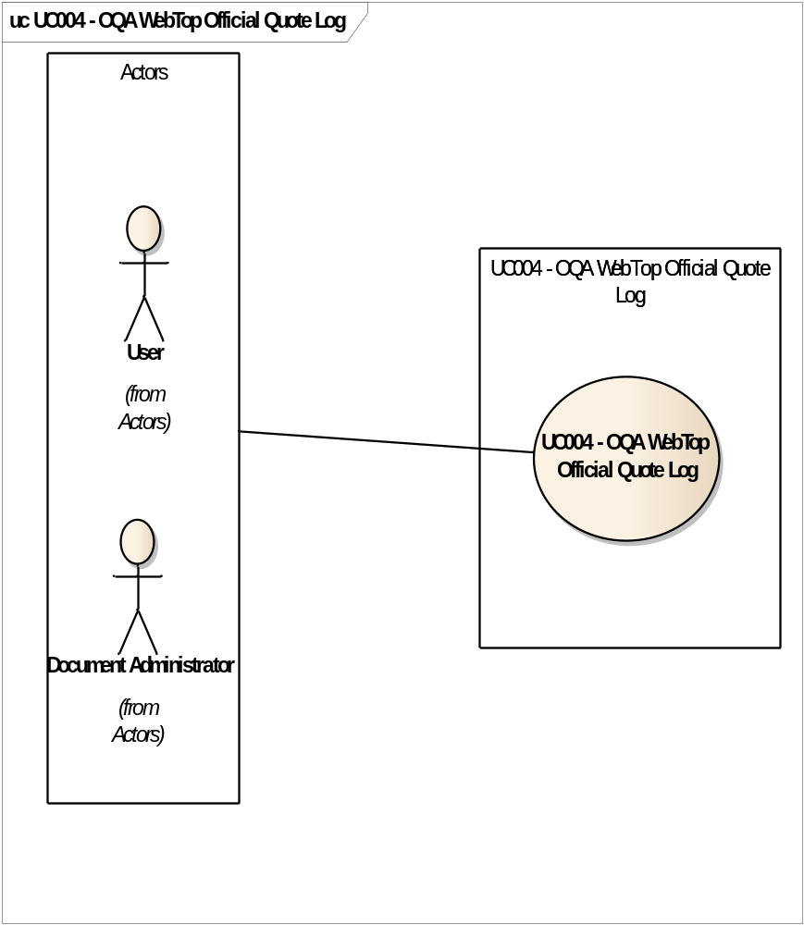
Figure 8: UC004 - OQA WebTop Official Quote Log

UC004 - OQA WebTop Official Quote Log ActivityGraph

Name | UC004 - OQA WebTop Official Quote Log ActivityGraph
Description | User views the Official Quote Log.
Primary Actor | Document Administrator
Minimum Constrains | User has administrator rights
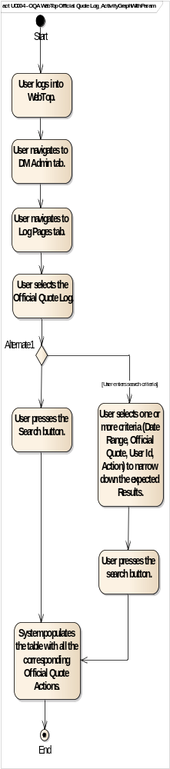
Figure 9: UC004 - OQA WebTop Official Quote Log ActivityGraph

UC005 - OQA WebTop Other Tables (MARS Official Quote)

Name | UC005 - OQA WebTop Other Tables (MARS Official Quote)
Description | User manages the MARS Official Quote Table.
Primary Actor | Document Administrator
Minimum Constrains | User has administrator rights

Scenario | Basic Path | Course | Basic Path

Step |  | Actor |  | Action
 | 1 |  | User |  | User logs into WebTop.

2 | User | User navigates to DM Admin tab.

3 | User | User navigates to Validation Tables tab.

4 | User | User navigates to Other Tables tab.

5 | User | User selects the MARS Official Quote table.

6 | System | System populates the table with the existing Official Quote records.

7 | User | User verifies the Add and Edit operations functionality.

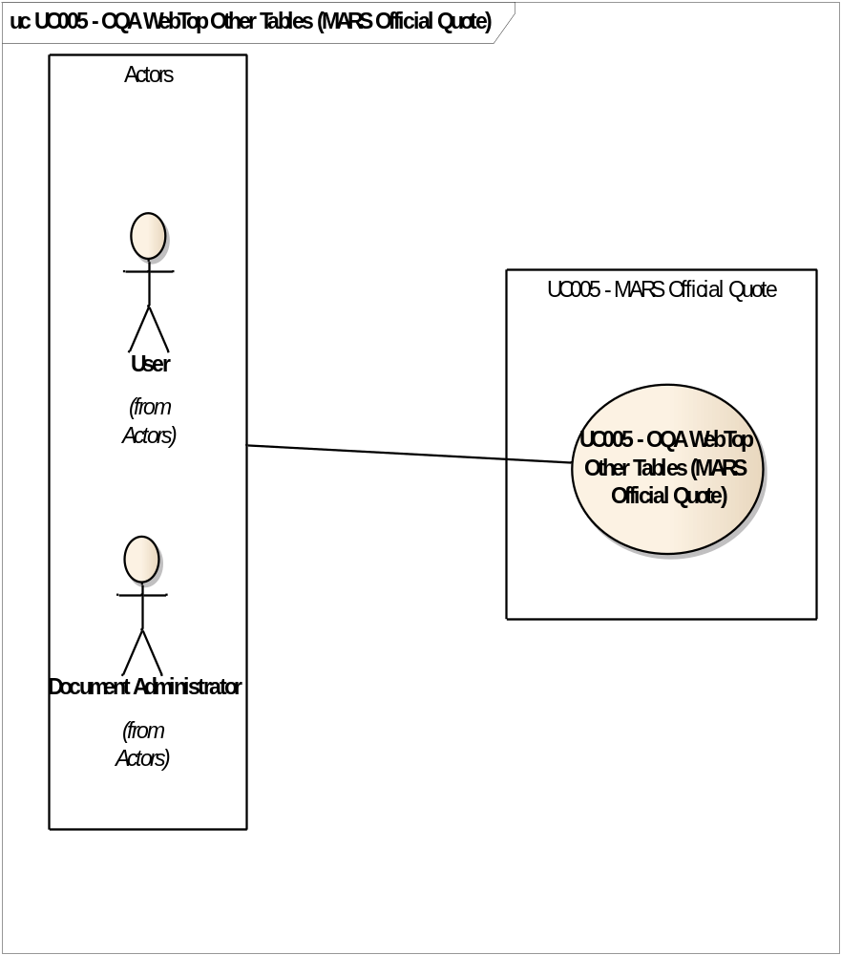
Figure 10: UC005 - OQA WebTop Other Tables (MARS Official Quote)

UC005 - OQA WebTop Other Tables (MARS Official Quote) ActivityGraph

Name | UC005 - OQA WebTop Other Tables (MARS Official Quote) ActivityGraph
Description | User manages the MARS Official Quote Table.
Primary Actor | Document Administrator
Minimum Constrains | User has administrator rights
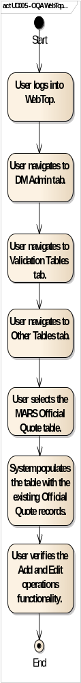
Figure 11: UC005 - OQA WebTop Other Tables (MARS Official Quote) ActivityGraph

UC006 - OQA WebTop Other Tables (MARS Official Quote Keyword)

Name | UC006 - OQA WebTop Other Tables (MARS Official Quote Keyword)
Description | User manages the MARS Official Quote Keyword Table.
Primary Actor | Document Administrator
Minimum Constrains | User has administrator rights

Scenario | Basic Path | Course | Basic Path

Step |  | Actor |  | Action
 | 1 |  | User |  | User logs into WebTop.

2 | User | User navigates to DM Admin tab.

3 | User | User navigates to Validation Tables tab.

4 | User | User navigates to Other Tables tab.

5 | User | User selects the MARS Official Quote Keyword table.

6 | System | System populates the table with the existing Official Quote Keywords.

7 | User | User verifies the Add and Edit operations functionality.

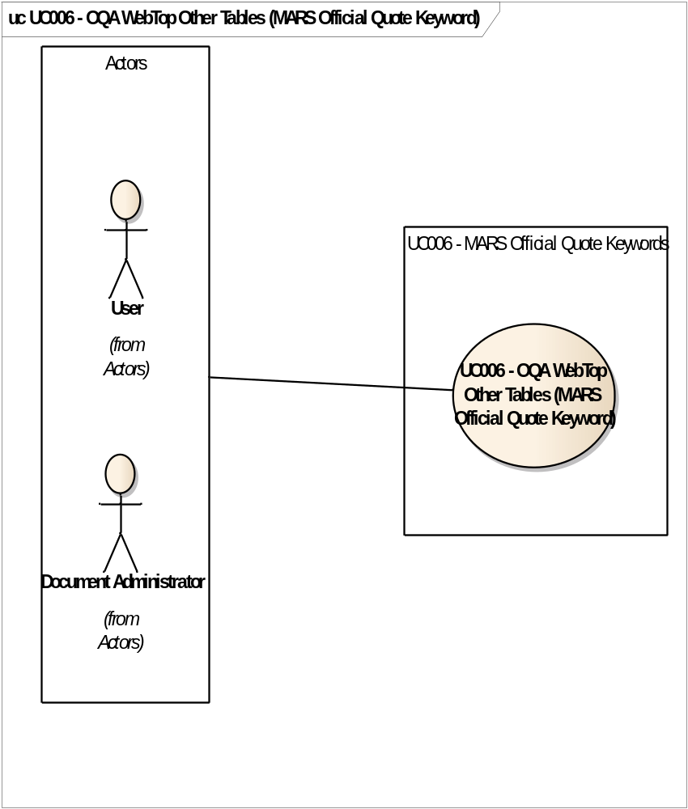
Figure 12: UC006 - OQA WebTop Other Tables (MARS Official Quote Keyword)

UC006 - OQA WebTop Other Tables (MARS Official Quote Keyword) ActivityGraph

Name | UC006 - OQA WebTop Other Tables (MARS Official Quote Keyword) ActivityGraph m
Description | User manages the MARS Official Quote Keyword Table.
Primary Actor | Document Administrator
Minimum Constrains | User has administrator rights
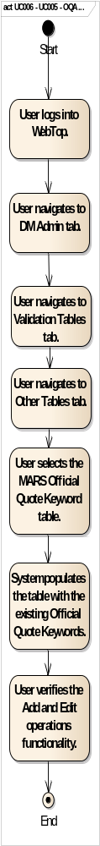
Figure 13: UC006 - UC005 - OQA WebTop Other Tables (MARS Official Quote Keyword) ActivityGraph

UC007 - OQA WebTop Other Tables (MARS Official Quote Prefix)

Name | UC007 - OQA WebTop Other Tables (MARS Official Quote Prefix)
Description | User manages the MARS Official Quote Prefix Table.
Primary Actor | Document Administrator
Minimum Constrains | User has administrator rights

Scenario | Basic Path | Course | Basic Path

Step |  | Actor |  | Action
 | 1 |  | User |  | User logs into WebTop.

2 | User | User navigates to DM Admin tab.

3 | User | User navigates to Validation Tables tab.

4 | User | User navigates to Other Tables tab.

5 | User | User selects the MARS Official Quote Prefix table.

6 | System | System populates the table with the existing Official Quote Prefixes records.

7 | User | User verifies the Add and Edit operations functionality.

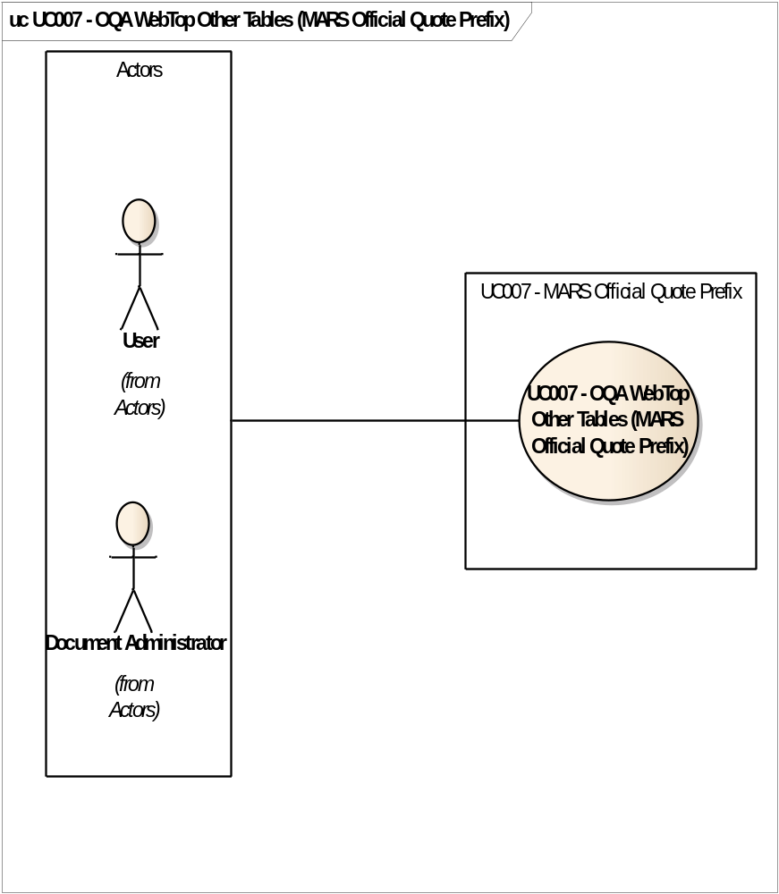
Figure 14: UC007 - OQA WebTop Other Tables (MARS Official Quote Prefix)

UC007 - OQA WebTop Other Tables (MARS Official Quote Prefix) ActivityGraph

Name | UC007 - OQA WebTop Other Tables (MARS Official Quote Prefix) ActivityGraph
Description | User manages the MARS Official Quote Prefix Table.
Primary Actor | Document Administrator
Minimum Constrains | User has administrator rights
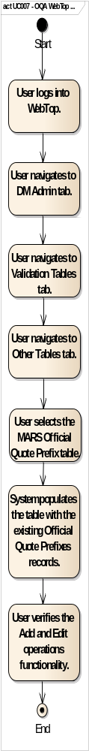
Figure 15: UC007 - OQA WebTop Other Tables (MARS Official Quote Prefix) ActivityGraph

UC008 - OQA WebTop Other Tables (MARS Official Quote Range)

Name | UC008 - OQA WebTop Other Tables (MARS Official Quote Range)
Description | User manages the MARS Official Quote Range Table.
Primary Actor | Document Administrator
Minimum Constrains | User has administrator rights

Scenario | Basic Path | Course | Basic Path

Step |  | Actor |  | Action
 | 1 |  | User |  | User logs into WebTop.

2 | User | User navigates to DM Admin tab.

3 | User | User navigates to Validation Tables tab.

4 | User | User navigates to Other Tables tab.

5 | User | User selects the MARS Official Quote Range table.

6 | System | System populates the table with the existing Official Quote Ranges records.

7 | User | User verifies the Add and Edit operations functionality.

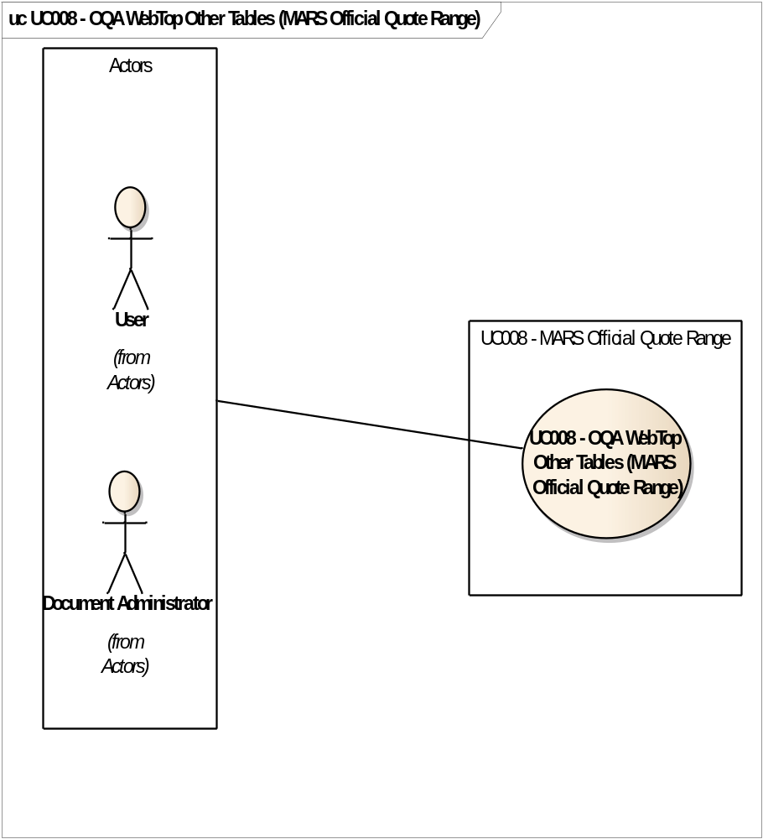
Figure 16:UC008 - OQA WebTop Other Tables (MARS Official Quote Range)

UC008 - OQA WebTop Other Tables (MARS Official Quote Range) ActivityGraph

Name | UC008 - OQA WebTop Other Tables (MARS Official Quote Range) ActivityGraph
Description | User manages the MARS Official Quote Range Table.
Primary Actor | Document Administrator
Minimum Constrains | User has administrator rights
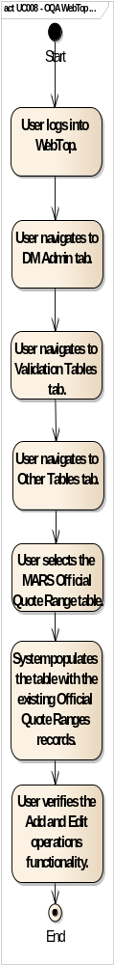
Figure 17: UC008 - OQA WebTop Other Tables (MARS Official Quote Range) ActivityGraph

